

Bachelor of Computer Applications
Semester – V
Business Analytics
Experiment No.: 1
Title: Importing business datasets from flat files & MySQL and
connecting with any other sources into Power BI

Submitted By:
Name: Keerthana R
Reg. No : 2411020240021
Date:22/8/2026

Submitted To:
Faculty Name: Mr. Aman Kumar Sharma

Department of Computer Application
Alliance University
Chandapura - Anekal Main Road, Anekal
Bengaluru – 562106

Experiment No.: 1
Problem Statement
You are a Data Analyst in a retail company. Sales data is stored in Excel files, customer data in CSV files, and product information in another source. Management wants a centralized reporting system. Import data from multiple sources into Power BI, establish the required connections, and prepare the data for business reporting.

Steps Followed

Step 1: Data Collection
• Obtained Sales Data from a CSV file downloaded from Kaggle.
• Obtained Customer Data from a CSV file downloaded from Kaggle.
• Obtained Product Data from a CSV file downloaded from Kaggle.
• Used the MySQL database as an additional data source for connecting business data to Power BI.

Step 2: Data Import
• Opened MySQL and imported the Sales, Customer, and Product CSV datasets downloaded from Kaggle.
• Stored the datasets as tables in the MySQL database.
• Opened Power BI Desktop.
• Connected Power BI to the MySQL database using the Get Data → MySQL Database option.
• Imported the required Sales, Customer, and Product tables from MySQL into Power BI.

Step 3: Data Cleaning and Transformation
- Removed duplicate records.
- Handled missing values.
- Renamed columns appropriately.
- Converted data types where necessary.

Step 4: Data Modeling
- Created relationships between Sales, Customer, and Product tables.
- Verified one-to-many relationships.
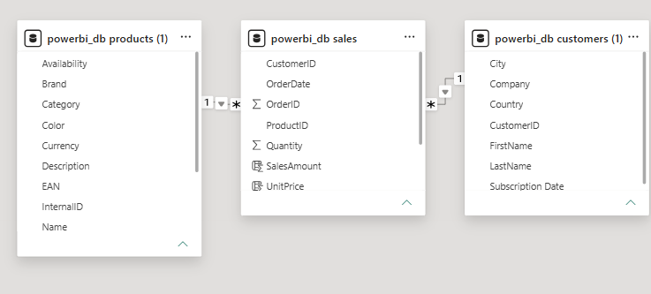

Step 5: Dashboard Development
• Created relationships between the Products, Sales, and Customers tables using the relevant key fields.
• Created DAX measures for Total Sales, Total Orders, and Total Customers.
• Created KPI cards to display key business metrics.
• Created charts to analyze Sales by Category, Sales by Country, Monthly Sales Trend, and Sales by Customer.
• Added Country, Category, and Order Date slicers to make the dashboard interactive.
• Applied a consistent grey colour theme to the dashboard.

Output
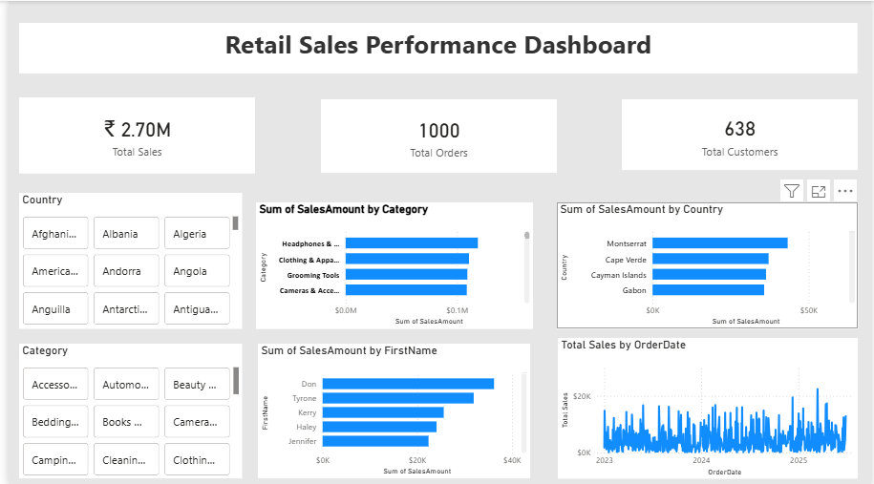
The final Power BI dashboard provides:
• Total Sales Performance through KPI cards.
• Total Orders and Customer Analysis using KPI cards.
• Product Category-wise Sales Analysis.
• Country-wise Sales Performance.
• Monthly Sales Trends.
• Customer-wise Sales Analysis.
• Interactive filters and slicers for Country, Category, and Order Date.
• A centralized and interactive view of the business data for easier analysis and reporting.

Conclusion
This experiment successfully demonstrated the process of importing business datasets into MySQL and connecting the database to Power BI for analysis and reporting. The Sales, Products, and Customers tables were connected using appropriate relationships. DAX and Power Query were used to prepare the data and create the required calculations.
The final dashboard provides an interactive view of sales performance, customer analysis, category-wise sales, country-wise sales, and monthly sales trends using KPI cards, charts, and slicers.

Learning Outcomes
Through this experiment, I learned:
- How to import CSV datasets into MySQL.
- How to connect MySQL with Power BI.
- How to work with multiple tables such as Sales, Products, and Customers.
- How to create relationships between tables in Power BI.
- How to use Power Query for data preparation and transformation.
- How to create DAX calculated columns and measures.
- How to create KPI cards, charts, and slicers.
- How to design an interactive Power BI dashboard.
- How to analyze business data and present it in a meaningful way.
These learning outcomes are consistent with the reference's emphasis on data import, Power Query, relationships, DAX, dashboards, and business insights.

